**Digital Image Processing – Homework #8**

**Juan Silva**

**ECE 595**

**November 13, 2019**

1. **Question 9.5**

With reference to the image shown, give the structuring element and morphological operation(s) that produced each of the results shown in images (a) through (d).

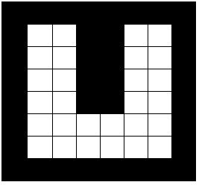

Show the origin of each structuring element clearly. The dashed lines show the boundary of the original set and are included only for reference. Note that in (d) all corners are rounded.

1. The image is eroded given a one-square SE.

 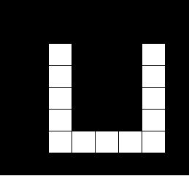

1. The image is eroded given an approximately six-square SE.

 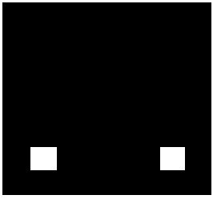

1. The image is eroded given an approximately four-square SE, then the image was dilated using a circular SE.

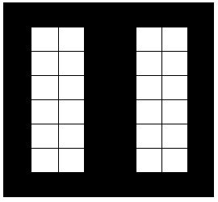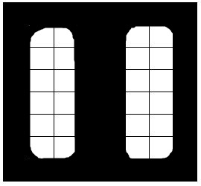

1. The image is diluted with a large circular SE to expand the white portion and then a smaller circular SE to dilute the black portion of the image.

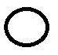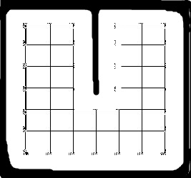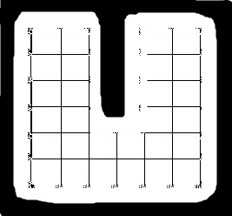

1. **Question 9.6**

Let denote the set shown shaded in the following figure. Refer to the structuring elements shown (the black dots denote the origin). Sketch the result of the following morphological operations:

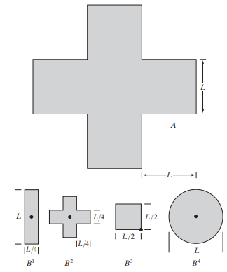

1. (⊕

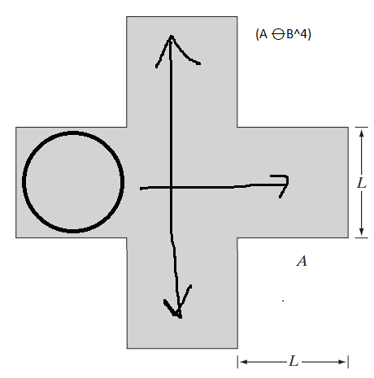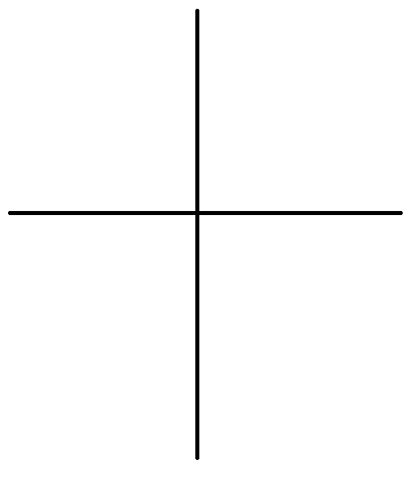



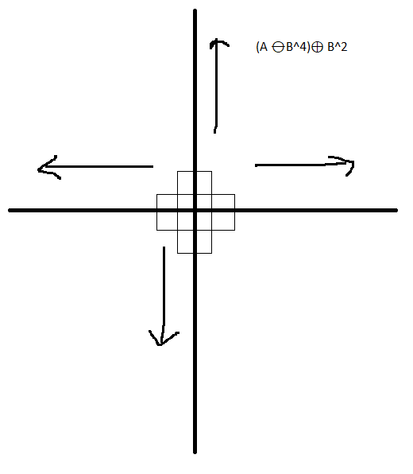

1. (⊕   
     
     
   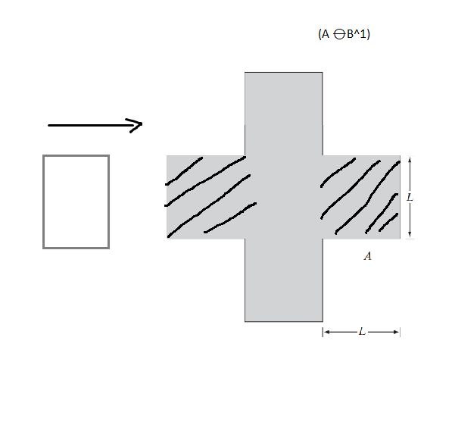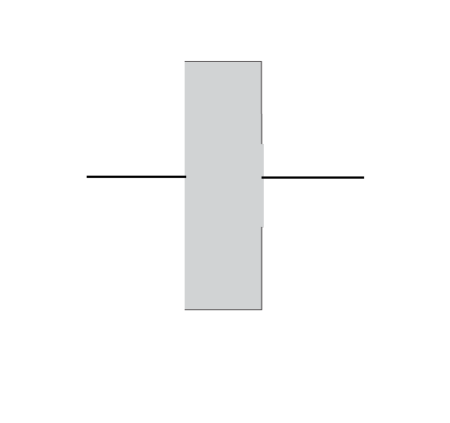  
   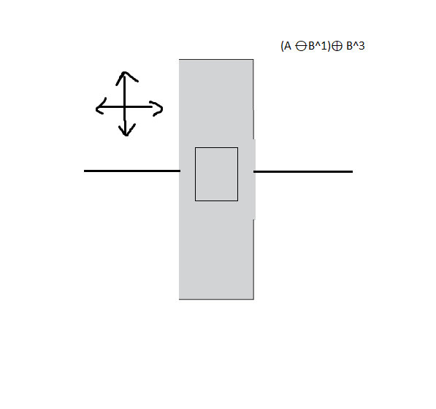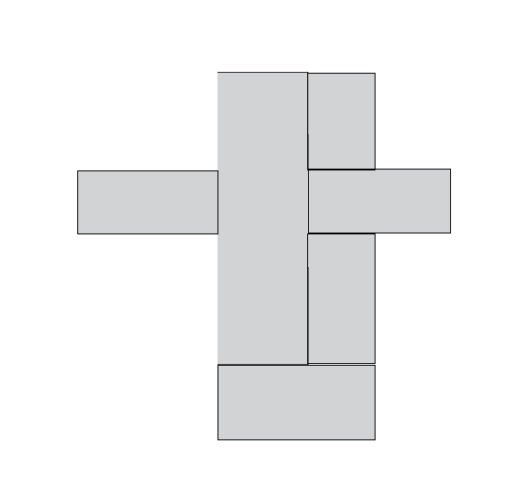
2. (⊕

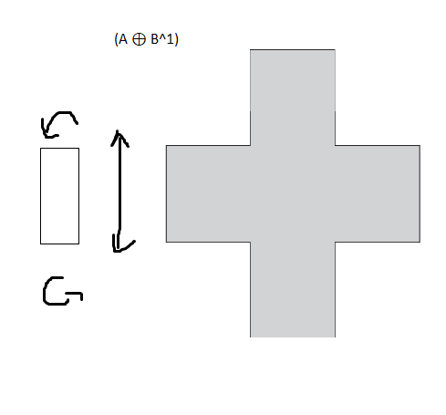 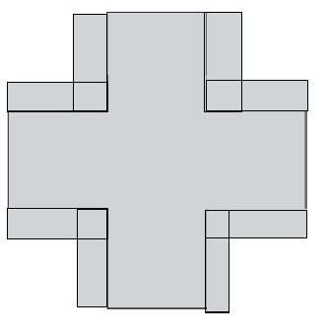

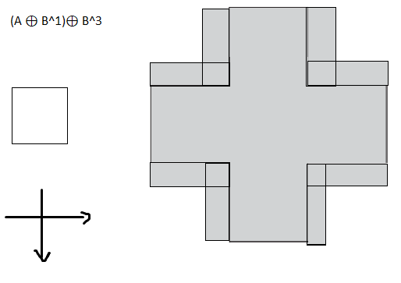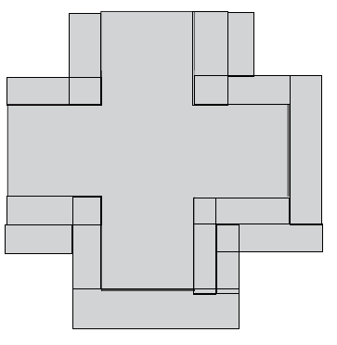

1. (

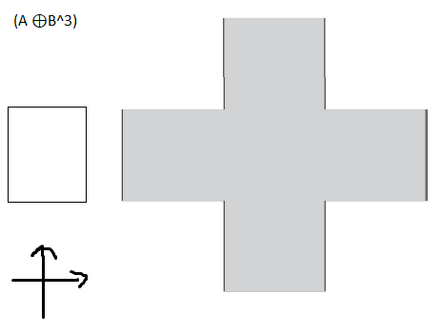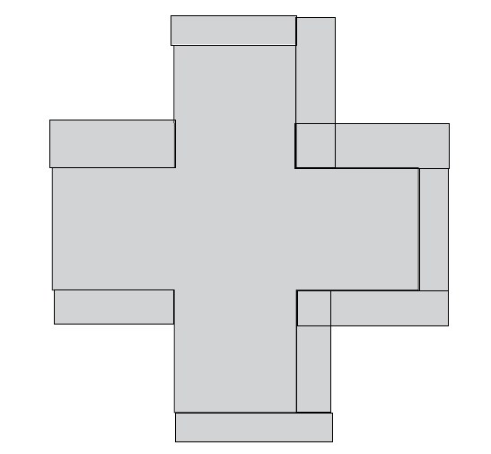

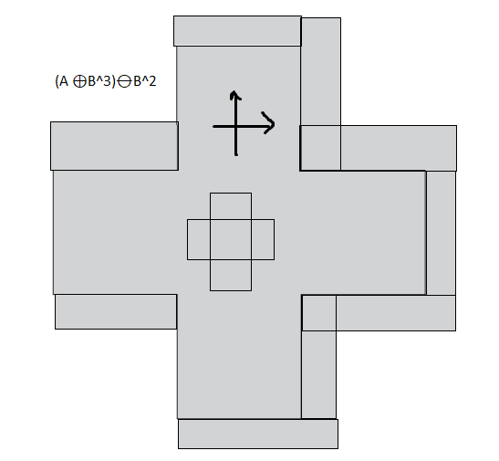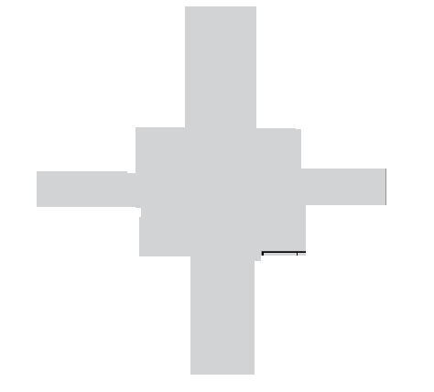

1. **Question 9.18**

Consider the three binary images shown in the following figure. The image on the left is composed of squares of sizes 1, 3, 5, 7, 9, and 15 pixels on the side. The image in the middle was generated by eroding the image on the left with a square structuring element of 1s, of size pixels, with the objective of eliminating all the squares, except the largest ones. Finally, the image on the right is the result of dilating the image in the center with the same structuring element, with the objective of restoring the largest squares. You know that erosion followed by dilation is the opening of an image, and you know also that opening generally does not restore objects to their original form. Explain why full reconstruction of the large squares was possible in this case.

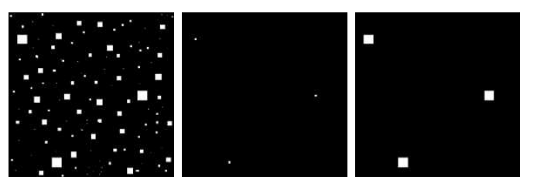

The 3 large squares are able to be fully reconstructed because they are not completely eroded due to their size. Since all the shapes within the image share the same shape and were eroded and diluted with a square SE, the largest squares can still “recover” even after being eroded using dilation. The dilation will enlarge the squares up until its original shape.

1. **Question 9.22**

(a) Discuss the effect of using the structuring element in Fig. 9.15(c) for boundary extraction, instead of the one shown in Fig. 9.13(b)

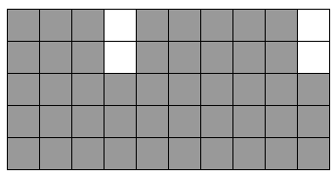 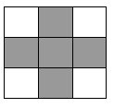

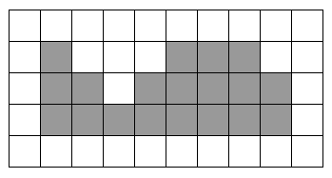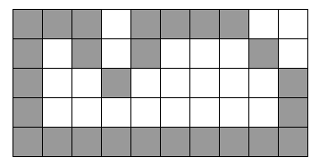

(b) What would be the effect of using a structuring element composed of all 1s in the hole filling algorithm of Eq. (9.5-2), instead of the structuring element shown in Fig. 9.15(c)?

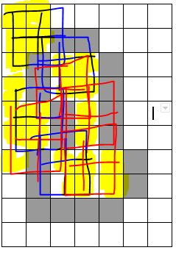

This would create distortion outside of the borders highlighted in yellow because the SE is creating elements after the dilation and the intersection of A’ will fill out of bounds.

